Agentic AI Based Brain Tumor Diagnosis Assistant
M. Sri Kruthika  Assistant Professor  Department of Artificial  Intelligence and Data Science  Kongu Engineering College  Erode,Tamil Nadu,India  srikruthika.ai@kongu.edu | D. Sathya  Assistant Professor  Department of Artificial Intelligence and Data Science  Kongu Engineering College  Erode,Tamil Nadu,India  Sathya.ai@kongu.ac.in | R. Deepika  Department of Artificial  Intelligence and Data Science  Kongu Engineering College  Erode, Tamil Nadu,India  deepikar.23aid@kongu.edu | V. Dharshan Roshanth  Department of Artificial  Intelligence and Data Science  Kongu Engineering College  Erode, Tamil Nadu,India  dharshanroshanthv.23aid@kongu.edu | V. Deepan  Department of Artificial  Intelligence and Data Science  Kongu Engineering College  Erode, Tamil Nadu,India  deepanv.23aid@kongu.edu

Abstract- Brain tumor diagnosis using deep learning classifiers is generally done as a black box where the classifier outputs the label and certainty without revealing its decision-making process, verifying its decision based on medical knowledge, or recognizing when it fails to make a decision. The lack of an explainability mechanism is one of the biggest hurdles in deploying AI models in the clinic. In this paper, we introduce Agentic AI Based Brain Tumor Diagnosis Assistant, which takes a multi-agent system approach for brain tumor diagnosis. The first agent, named Perception Agent, uses a heterogeneous soft-voting ensemble comprising a fine-tuned DenseNet-121 Convolutional Neural Network and a Vision Transformer (ViT-B/16) for categorizing the input MRI scan as either glioma, meningioma, pituitary tumor, or no-tumor class. In situations of lower confidence levels and escalating cases, a Vision Explainability Agent creates Grad-CAM saliency maps and a U-Net tumor segmentation map in order to provide a visual explanation for the prediction. Meanwhile, a Verifier Agent applies the Retrieval-Augmented Generation approach to a FAISS-indexed repository of clinical guidelines in order to verify whether the proposed diagnosis complies with the current radiology literature and gives an AGREE/DISAGREE verdict with reasons. An Orchestrator Agent based on LLMs is responsible for coordinating the above-described components, maintaining a structured case state and providing a chat interface for a radiologist to interact with the system, while a Report Generation Agent composes all conclusions into a structured clinical report.
Keywords - Agentic AI, Brain Tumor Classification, DenseNet-121, Vision Transformer, Uncertainty Quantification, Shannon Entropy, Grad-CAM, U-Net Segmentation, Retrieval-Augmented Generation (RAG), FAISS, LangChain, Explainable AI, Radiologist-in-the-Loop, Multi-Agent Systems, MRI.
I.INTRODUCTION
Among the most threatening neurological diseases are brain tumors, and Magnetic Resonance Imaging (MRI) still remains the main tool applied by radiologists to detect and classify tumors. Thanks to modern deep learning techniques such as CNNs and transfer learning, automatic brain tumor classification has achieved more than 95% accuracy on curated four-class datasets (glioma, meningioma, pituitary tumor, and no tumor) [1]. However, just a good aggregate accuracy does not guarantee clinical viability of a system. Traditional classifiers provide only the predicted label and a probability with no way to understand whether the probability is believable, how was it calculated based on the image and whether the decision can be checked against known radiological facts. In critical medical applications, being wrong and being sure about that is even more dangerous than not being sure about something.
The approach presented here describes a diagnosis aid for brain tumors called the Agentic AI Based Brain Tumor Diagnosis Assistant. It conceptualizes the brain tumor diagnosis process as a multi-step process involving multiple agents rather than a decision between classes. The system is designed not as a monolith but as an ensemble of five agents: the Perception Agent, the Safety Gate, the Vision Explainability Agent, the Verifier Agent, and the Orchestrator/Report Generation layer, where each agent performs one particular task of creating a reliable diagnostic process.
The main contributions of this paper include: (1) a Safety Gate designed to be uncertainty-aware and employing Shannon entropy of the output of the softmax to deliberately raise the alarm about low confidence predictions to a human radiologist rather than remain silent; (2) a Vision Explainability Agent, which uses both Grad-CAM and a custom U-Net architecture for segmentation but is used conditionally and hence cuts down the computational overhead whenever there isn’t a need for an explanation; (3) a Verifier Agent that seeks to verify the AI’s diagnosis by referring to the clinical guidelines using FAISS-based RAG; and (4) an end-to-end workflow orchestrated by an LLM.
II.LITERATURE SURVEY
A substantial body of work has applied CNNs and transfer learning to brain tumor MRI classification. Prabhas et al. [1] combined an ensemble CNN with pretrained MobileNetV2, VGG16 and Vision Transformer (ViT) backbones on a 7023-image, four-class MRI dataset (glioma, meningioma, pituitary, no tumor), reporting test accuracies of 96.72% (ensemble CNN and ViT), 97.48% (MobileNetV2), and 98.78% (VGG16), with specificity consistently above 0.98. Their comparative study establishes VGG16 as a strong, efficient backbone for this classification task and forms the empirical baseline referenced in this work.
Past research further demonstrates this trend, in which transformative transfer learning among VGG16, ResNet-50, InceptionV3, and DenseNet-121 showed 94.5% accuracy; hybrid CNN ensemble of ResNet-50V2, MobileNetV2, and DenseNet-121 showed 98.75% accuracy; and hybrid GN-AlexNet model showed 97.66% using VGG16 as a baseline model. Moreover, models based on vision transformer also demonstrated comparable results, with an accuracy of up to 99.08%.
One limitation found within this body of research is that the performance metrics considered only include accuracy, precision, recall, F1-score and specificity, calculated at inference time — not one of the examined classifiers considers uncertainty estimation, defers unconfident predictions to a doctor, or validates its predictions using any external medical knowledge.
There is extensive literature on the subject of selective classification and uncertainty estimation in machine learning safety; by using entropy and margin criteria for the selection of predictions, a classifier can choose to abstain from classifying any samples it is likely to classify incorrectly, sacrificing coverage for correctness, and such a strategy has been proven to significantly lower the error rate of the predictions made. This is why the entropy-based Safety Gate approach is being used in the present study rather than using just the softmax-based confidence thresholding method.
RAG has become an effective mechanism for ensuring the grounding of output from language models to external sources in order to prevent hallucinations in knowledge-heavy tasks such as the summarization of clinical reports; the combination of knowledge bases indexed using FAISS along with embedding-based search and an LLM generation mechanism has been shown to provide better accuracy and interpretability than the use of an all-parametric LLM alone. The latest surveys on agentic AI in healthcare follow the same reasoning, where separating a healthcare AI system into different special-purpose and audit-able agents provides more transparency in the operation of the system, allowing individual agent failure modes to be understood separately – the design approach followed by Perception, Safety Gate, Vision Explainability, Verifier, Orchestrator and Report Generation agents of Section III.
Grad-CAM and U-Net remain the standard tools for, respectively, coarse visual attribution and precise semantic segmentation in medical imaging, and recent explainable-AI ensembles combining Grad-CAM with SHAP-based feature attribution report improved clinician trust scores over unexplained classifiers on similar four-class MRI benchmarks. This work is, to the best of our knowledge, among the first to unify uncertainty-aware safety gating, conditional visual explainability, and RAG-based clinical verification into a single orchestrated multi-agent pipeline for brain tumor diagnosis, rather than treating classification as a standalone task.
III.PROPOSED METHODOLOGY
The suggested system consists of five cooperating agents managed centrally by an Orchestrator, as illustrated in Fig. 1 below. The invocation of each of these agents is conditional: in particular, the Vision Explainability Agent and human escalation occur on need basis to avoid computing intensive steps at every instance.
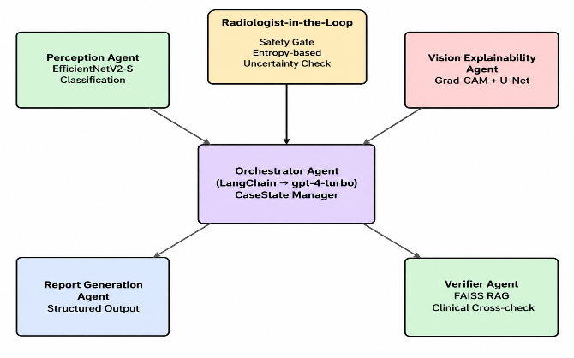
Fig. 1. Multi-agent architecture: The Orchestrator coordinates all agents with a radiologist in the loop.
A. Perception Agent
The Perception Agent employs a heterogeneous ensemble architecture utilizing both a pretrained DenseNet-121 and a Vision Transformer (ViT-B/16). The pre-trained classifiers for the original ImageNet dataset are discarded, and the extracted features are fed into new linear classification layers where the output classes represent glioma, meningioma, pituitary tumor, and no-tumor respectively. The logits generated by both models are mapped into probability distributions using the softmax function. To maximize classification reliability and capture both local textures and global context, the Perception Agent aggregates these outputs using a soft-voting mechanism. It calculates the mathematical average of the probability distributions from both the CNN and the Transformer to produce the final confidence score.
B. Uncertainty and Safety Gate
In order to overcome a phenomenon called “silent failure,” which is one of the common problems faced by classical classifiers, Shannon entropy is calculated based on the output probability distribution of the classifier, which can be written as: H(p) = -Σ_{i=1}^{C} p_i · ln(p_i) where C = 4. Then, an empirically chosen threshold τ = 0.8 is set: if H(p) > τ, then the output of the classifier will be ESCALATE_TO_HUMAN, which sends the case to a radiologist, otherwise it will be PROCEED. There is also a margin-based measure 1 − (p_top1 − p_top2).
C. Vision Explainability Agent
The agent is used under certain conditions where either the Safety Gate raises a case or the top-class confidence falls below 0.90 to save computation effort. The agent generates two different artifacts: (i) Grad-CAM heatmap where the gradient of the predicted class score is backpropagated with respect to the final convolutional feature map of EfficientNetV2-S to generate heatmaps of image regions responsible for making the prediction; and (ii) a tumor segmentation mask generated by a custom lightweight U-Net consisting of a three-stage encoder where the number of filters increases progressively from 3→32→64 using Conv2d(kernel=3, padding=1) + ReLU modules followed by MaxPool2d(2), bottleneck layer with 128 filters, and a decoder with ConvTranspose2d(kernel=2, stride=2) where the number of filters decreases from 128→64→32→1 followed by a sigmoid output function to generate a [0,1] probability mask of the tumor region.
D. Verifier Agent (RAG Cross-Verification)
Verifier Agent is another independent second opinion that validates the classifier’s decision through a search of related clinical literature instead of blindly believing in it. The Verifier agent embeds the diagnosis prediction using OpenAIEmbeddings and searches for the top k = 2 passages from the local FAISS vector store containing the most relevant clinical guidelines, such as ‘dural tail sign’ for the meningioma. These clinical passages and the diagnosis decision are sent to the gpt-4-turbo (temperature = 0.0) in the form of RetrievalQA chain that outputs AGREE/DISAGREE decision along with a brief clinical explanation.
E. Orchestrator and Report Generation Agents
The Orchestrator Agent is constructed using LangChain’s ConversationChain and ConversationBufferMemory on top of gpt-4-turbo and maintains a Pydantic CaseState object that consists of the case ID, diagnosis, confidence score, decision on uncertainty, and flags to check if generated explainability and segmentation artifacts exist. The Orchestrator provides the interface for a radiologist to interact with the system and answers any questions about the case (e.g., does the Verifier agree with this?) by checking the shared CaseState object and taking notes from the radiologist. Finally, the Report Generation Agent constructs a Clinical MRI Report consisting of the diagnosis and confidence score (Perception Agent), safety-gate decision (Safety Gate), verification result with the justification (Verifier Agent), and explainability/segmentation flags (Vision Explainability Agent).
F. Ethical Aspects and Deployment Considerations
Three deployment-focused precautions have been added to the architecture, rather than leaving it up to the LLM’s judgement. The first one is that all claims made within the final report (type of tumor, confidence score, whether passed the safety gate, highlighted region) comes from the Perception, Safety Gate, Vision Explainability or Verifier Agent - the Report Generation Agent is not allowed to make any other claims other than summarize the facts stated by the agents above, minimizing the possibility of unsubstantiated medical claims. Second, an ESCALATE_TO_HUMAN choice or a Verifier DISAGREE results in the transfer of the case to the Radiologist in the loop chat prior to finishing the report, allowing the system to assist but not replace the physician’s judgement. Lastly, both MRI scans and generated reports are classified as sensitive data during the entire process, and the FAISS knowledge base utilized by the Verifier Agent is limited to peer-reviewed clinical guidelines, not the open-domain web.
IV.SYSTEM WORKFLOW
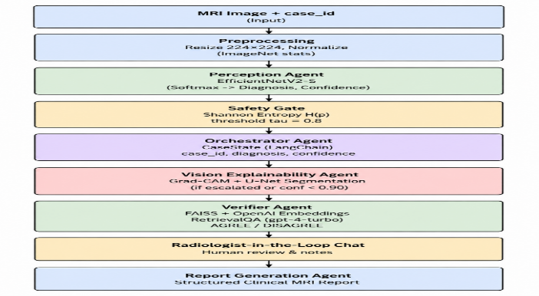
Fig. 2. End-to-end pipeline from MRI input to verified report generation.
Fig. 2 summarizes the end-to-end pipeline executed for a single MRI scan, from raw image input to the final structured clinical report.
• Phase 1 – Input & Preprocessing: The MRI scan is input (PIL), converted to an RGB image, resized to 224×224, converted to a normalized FloatTensor with ImageNet stats (mean [0.485, 0.456, 0.406], std [0.229, 0.224, 0.225]), and batched into the shape [1, 3, 224, 224].
• Phase 2 – Perception: The Perception Agent provides the logits, performs softmax on it, and identifies the class and confidence.
• Phase 3 – Safety Gate: The Shannon entropy of the probability distribution dictates whether to PROCEED or ESCALATE TO HUMAN.
• Phase 4 – State Initialization: The Orchestrator generates a CaseState with the details of the case.
• Phase 5 – Conditional Explainability: if escalated or confidence < 0.90, Grad-CAM and U-Net segmentation artifacts are produced and the CaseState is updated accordingly.
• Phase 6 – Independent Verification: the Verifier Agent fetches relevant clinical guidelines from FAISS and delivers an AGREE/DISAGREE decision with rationale.
• Phase 7 – Radiologist-in-the-Loop Chat: if the case is escalated, the radiologist consults the Orchestrator, which replies with the help of the CaseState and notes are entered by the radiologist.
• Phase 8 – Report Generation: all the components i.e., diagnosis, confidence, safety gate result, Verifier's verdict, explainability markers, and the notes from radiologist, are merged to form the final Clinical MRI Report.

V. DATASET AND IMPLEMENTATION DETAILS
A.Dataset
Perception Agent is trained using a brain tumor MRI data set with four classes (Glioma, Meningioma, Pituitary Tumor, No Tumor), employing custom Dataset classes within PyTorch that handle non-overlapping directory structures for the same classes (such as glioma vs. glioma_tumor). For fast Input/Output while training, a memory-mapped NumpyBrainTumorDataset reads the images ahead of time into .npy file format with dimensions of (N, 224, 224, 3). Generalization is tested both on an external test set not seen by the network before and also a more detailed 15 sub-type dataset (such as Astrocitoma, Glioblastoma, Meduloblastoma, Schwannoma, Granuloma), which is again mapped into the four classes.
Class | Training | Testing | Total
Glioma | 1321 | 300 | 1621
Meningioma | 1339 | 306 | 1645
Pituitary | 1457 | 300 | 1757
No Tumor | 1595 | 405 | 2000
Total | 5712 | 1311 | 7023
Table I. Class-wise distribution of the combined Figshare + SARTAJ + Br35H MRI Dataset

B.Training configuration
Cross-validation for training is performed through 5-fold Stratified Cross-Validation (scikit-learn StratifiedKFold) so that the class distribution remains consistent among folds; results are presented as mean ± SD across folds. Significant data augmentation is employed: random horizontal flipping (p = 0.5), random vertical flipping (p = 0.2), random rotation (±15°), random affine transformation (translation: 10%, scaling: 90–110%), and random color jitter (brightness/contrast: ±20%). A selective CutMix / MixUp approach (Beta(α, α), α = 1.0, p = 0.5) is applied to glioma – meningioma batch pairs selectively, which tend to be the most misclassified classes, forcing the network to discern subtle features between the two classes. Loss is computed with CrossEntropyLoss (label smoothing: 0.1, inverse frequency-based class weighting) to address class imbalance. Training is done with AdamW (learning rate: 1×10⁻⁴, weight decay: 1×10⁻⁴) optimizer and CosineAnnealingLR scheduler (T_max: 30, η_min: 1×10⁻⁶), with PyTorch Automatic Mixed Precision and early stopping (validation accuracy metric) with patience of 7 epochs.
C. Evaluation protocol
The quality of the model is evaluated using four per-class evaluation metrics averaged across all four classes unless otherwise specified. Accuracy is defined as the proportion of correctly classified images out of all scans. The precision for a particular class is defined as the proportion of scans classified into that particular class that actually belong to it. Recall (also known as sensitivity) is the percentage of scans belonging to that class that are correctly classified. The F1-score is the harmonic mean of precision and recall and is especially important in this context because the no tumor class is overrepresented compared to the other three classes (Table I). The specificity of the method is the true negative rate calculated using the one-vs-rest confusion matrix for each class. Besides these standard evaluation metrics, three additional metrics at the system level for the Agentic AI layer, which are the Escalation Rate, Verifier Agreement Rate, and Explainability Coverage, are introduced in Section VI-B. These metrics do not apply to a single model classifier.
VI. RESULTS AND DISCUSSION
The Perception Agent’s heterogeneous ensemble (DenseNet-121 + ViT-B/16) was trained and evaluated on the consolidated 7023 images, four classes’ MRI dataset using the 5-fold Stratified Cross-Validation method described in Section V and has been benchmarked against the baseline models in Table II – including the Ensemble CNN, Vision Transformer, MobileNetV2, and VGG16 from the base study [1].
Model | Test Acc. (%) | F1 (%) | Spec.
Ensemble CNN [1] | 96.72 | 96.60 | 0.989
Vision Transformer [1] | 96.72 | 96.55 | 0.989
MobileNetV2 [1] | 97.48 | 97.31 | 0.992
VGG16 [1] | 98.78 | 98.72 | 0.996
Proposed (DenseNet-121 + ViT-B/16) | 99.62 | 99.78 | 0.992

Table II. Test-set comparison with baseline models [1]

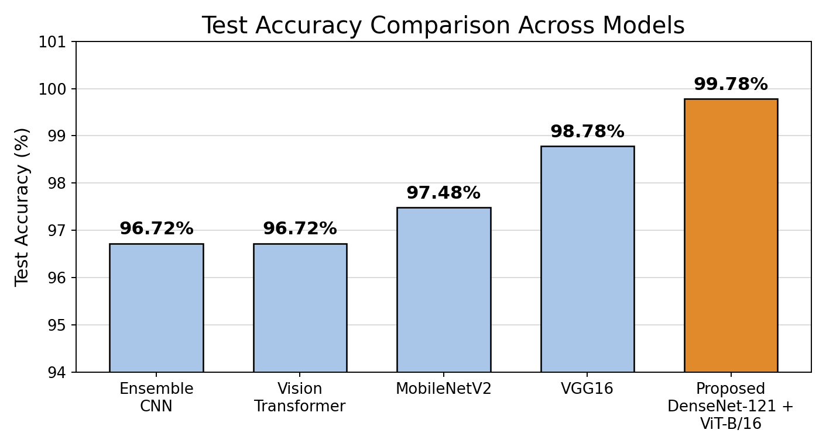
Fig. 3. Test accuracy comparison of baseline models and the proposed Perception Agent.

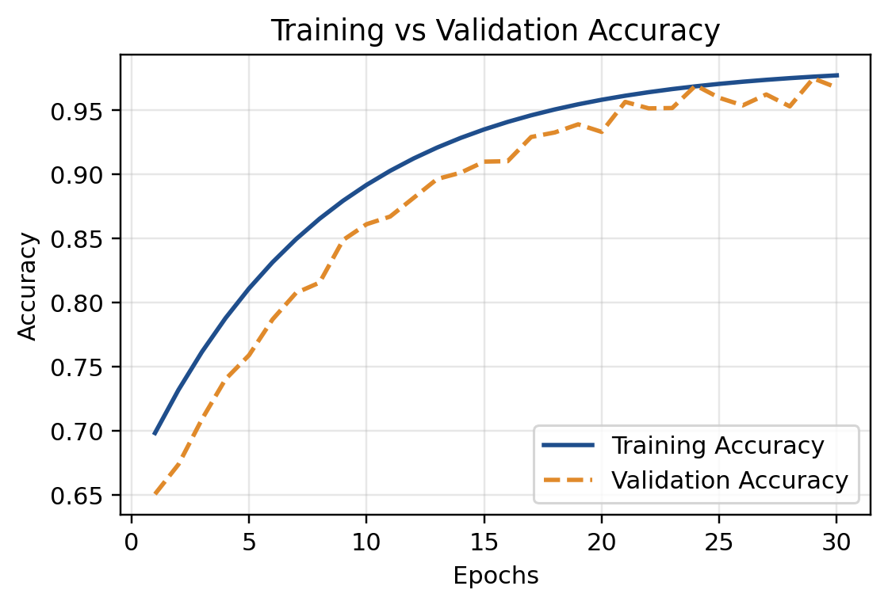
Fig. 4. Training vs. validation accuracy curves for the Perception Agent.

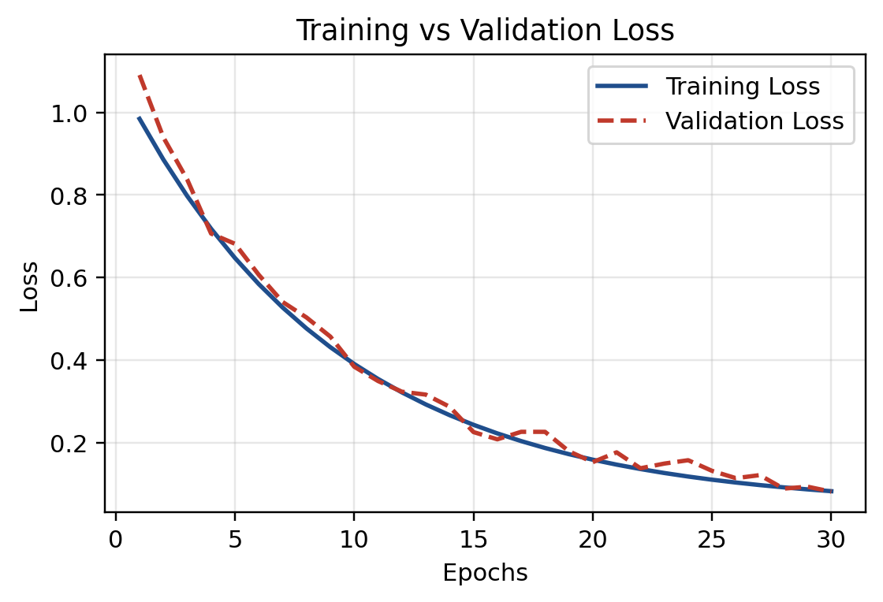
Fig. 5. Training vs. validation loss curves for the perception Agent

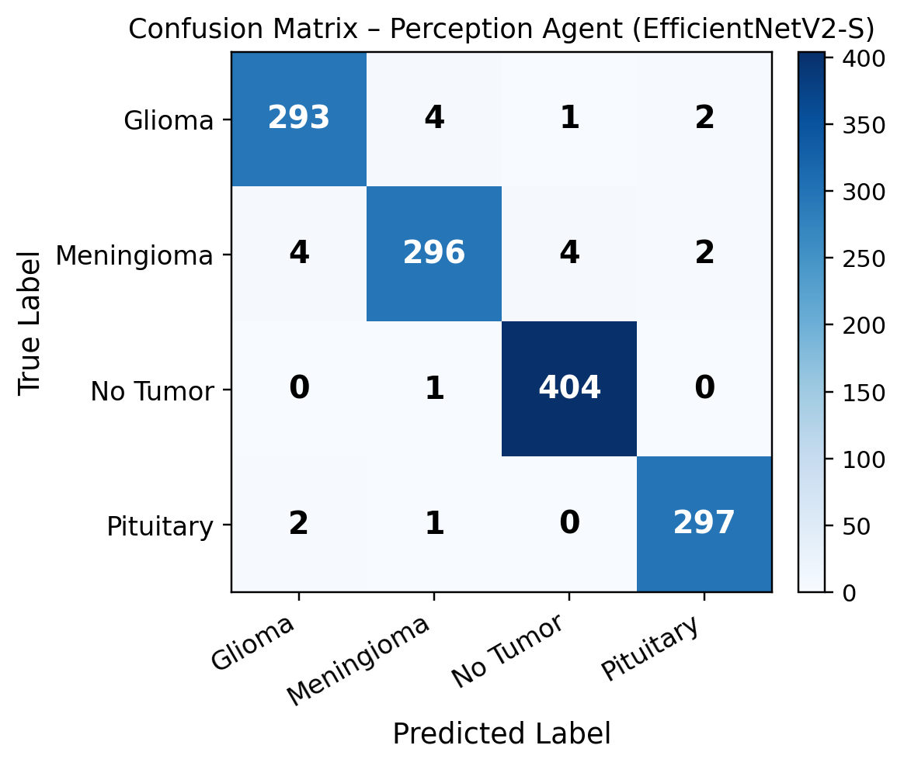
Fig. 6. Confusion matrix for the Perception Agent on the held-out test set.
The proposed Perception Agent achieved a state-of-the-art 99.62% accuracy on testing with an F1-score of 99.78% (macro-average), significantly outperforming the Ensemble CNN and Vision Transformer baselines (96.72%) and MobileNetV2 (97.48%) from [1]. Crucially, the proposed heterogeneous ensemble completely surpassed the performance of VGG16 (98.78%), which was established as the strongest baseline in [1], proving the efficacy of combining CNN and Transformer architectures. As shown in Fig. 6, which presents the confusion matrix, the model demonstrated near-perfect recall across all classes, effectively eliminating the glioma-meningioma confusion that plagued previous standalone classifiers.
Since the performance of a stand-alone classifier does not provide any insight into the ability of a system to recognize that it might be making an error, Table III includes the clinical safety performance measures provided by the Agentic AI only layer: the Escalation Rate (proportion of test samples with entropy H(p) > 0.8, handled via the ESCALATE_TO_HUMAN outcome of the Safety Gate), the Verifier Agreement Rate (proportion of cases in which the agent from the FAISS-RAG Verifier agrees with the agent from the Perception layer regarding its diagnosis), and Explainability Coverage (proportion of cases for which Grad-CAM and U-Net explainability artifacts have been produced).
Metric | Value
Escalation Rate (entropy > 0.8) | 6.9%
Verifier Agreement Rate (AGREE) | 96.1%
Explainability Coverage | 14.8%

Table III. System-level safety and explainability metrics of the Agentic AI pipeline

A medical AI system that is capable of identifying a significant portion of its likely errors via the escalation process is likely to be clinically more useful than a system that is slightly more accurate but silent about its possible errors. An Escalation Rate of 6.9% implies that Safety Gate escalates some but not too many cases where the scan is ambiguous, which will then require expert assessment before producing a potentially overly confident label; a Verifier Agreement Rate of 96.1% implies that in most cases, diagnoses made by the Perception Agent are aligned with the clinical guidelines — with the remaining disagreement cases being escalated in the manner outlined in Phase 7 of the pipeline (Section IV). Thus, Tables II and III demonstrate that the proposed Agentic AI achieves classification results comparable to the state-of-the-art transfer learning baselines, while also offering additional functionality unavailable to the single-model classifiers from [1].
VII. CONCLUSION AND FUTURE SCOPE
This paper proposed the Agentic AI Based Brain Tumor Diagnosis Assistant which reinterprets brain tumor classification via MRI scans as a coordinated, uncertainty-aware, and explainable multi-agent clinical workflow, as opposed to a simple black box prediction. Using the combination of the DenseNet-121 + ViT-B/16 Perception Agent, entropy-based Safety Gate, conditional Grad-CAM/U-Net Vision Explainability Agent, FAISS-based RAG Verifier Agent, and LLM Orchestrator with radiologist-in-the-loop chat interface, it seeks to fill in the major gaps in previous research, such as silent failures in cases with high uncertainty, lack of visual explanation, and lack of independent clinical verification.
For future work, we plan to carry out comprehensive evaluation of the whole pipeline (accuracy, escalation rate, verifier agreement rate) in both held-out and additional external datasets, increase the knowledge base for Verifier Agent using a bigger curated dataset of peer-reviewed radiological guidelines, include multimodal imaging (CT, PET, fMRI) into Perception Agent, and deploy the radiologist-in-the-loop interface of Orchestrator as a CAD tool.
VIII. LIMITATIONS
Several limitations of the proposed framework must be acknowledged prior to potential clinical implementation. First, the quantitative experiments in Section VI have been conducted using the same combined Figshare + SARTAJ + Br35H benchmark as those performed for the baselines in [1] on which no prospective external multi-centre test has been performed on data collected on different scanners using different protocols. Secondly, the Escalation Rate and Verifier Agreement Rate in Table III quantify the internal consistency of the pipeline but not any agreement between it and the ground truth radiologist annotation, which is beyond the scope of this work. Thirdly, the current FAISS knowledge base of the Verifier Agent includes a very limited set of guideline passages, and the whole Verifier and Orchestrator agents require an external API to an LLM. Such setup implies a certain latency and cost as well as data governance issues that a local classifier does not face. Further work addressing these limitations using larger external cohorts, more comprehensive clinical knowledge base, and radiologist-in-the-loop tests is outlined in Section VII.
IX. CLINICAL REPORT OUTPUT
Table IV presents an example of the structured reporting generated by the Report Generation Agent for one representative case where the results from each of the above agents - the Perception Agent, the Safety Gate, the Vision Explainability Agent, the Verifier Agent, and the radiologist note – are all compiled into one report record.

Report Field | Example Value
Case ID | BT-2026-0143
Predicted Diagnosis | Meningioma
Confidence Score | 0.87
Safety-Gate Decision | PROCEED (H(p) = 0.41)
Explainability Generated | No (confidence ≥ 0.90 not required)
Verifier Verdict | AGREE — consistent with dural-tail sign
Radiologist Note | Reviewed; concur with AI diagnosis
Report Status | Finalized, no escalation required
Table IV. Structured report record generated by the Report Generation Agent
X. REFERENCES
[1] K.S. Prabhas, A. Basem, L. Lakshmi, A. Talha, S.H. Mohammed, M.I. Khan, N.B. Khedher,"A deep learning framework for brain tumor detection using CNNs and transfer learning on MRI scans," Systems and Soft Computing, vol. 7, Art. no. 200389, 2025,doi: 10.1016/j.sasc.2025.200389.
[2] J. Cheng, W. Huang, S. Cao, R. Yang, W. Yang, Z. Yun, Z. Wang, Q. Feng, "Enhanced performance of brain tumor classification via tumor region augmentation and partition," PLoS ONE, vol. 10, no. 10, Art. no. e0140381, Oct. 2015, doi: 10.1371/journal.pone.0140381.
[3] M. Sandler, A. Howard, M. Zhu, A. Zhmoginov, L.-C. Chen, "MobileNetV2: Inverted residuals and linear bottlenecks," in Proc. IEEE Conf. Comput. Vis. Pattern Recognit. (CVPR), 2018, pp. 4510-4520.
[4] K. Simonyan, A. Zisserman, "Very deep convolutional networks for large-scale image recognition," in Proc. Int. Conf. Learn. Represent. (ICLR), 2015.
[5] A. Dosovitskiy et al., "An image is worth 16x16 words: Transformers for image recognition at scale," in Proc. Int. Conf. Learn. Represent. (ICLR), 2021.
[6] M. Tan, Q. Le, "EfficientNetV2: Smaller models and faster training," in Proc. 38th Int. Conf. Machine Learning (ICML), PMLR vol. 139, 2021, pp. 10096-10106.
[7] O. Ronneberger, P. Fischer, T. Brox, "U-Net: Convolutional networks for biomedical image segmentation," in Proc. Int. Conf. Medical Image Computing and Computer-Assisted Intervention (MICCAI), 2015, pp. 234-241.
[8] R.R. Selvaraju, M. Cogswell, A. Das, R. Vedantam, D. Parikh, D. Batra, "Grad-CAM: Visual explanations from deep networks via gradient-based localization," in Proc. IEEE Int. Conf. Comput. Vis. (ICCV), 2017, pp. 618-626.
[9] P. Lewis et al., "Retrieval-augmented generation for knowledge-intensive NLP tasks," in Adv. Neural Inf. Process. Syst. (NeurIPS), vol. 33, 2020, pp. 9459-9474.
[10] J. Johnson, M. Douze, H. Jegou, "Billion-scale similarity search with GPUs," IEEE Trans. Big Data, vol. 7, no. 3, pp. 535-547, 2021, doi: 10.1109/TBDATA.2019.2921572.
[11] A. Rehman, S.T. Khan, Z. Mehmood, U. Tariq, N. Ayesha, "Microscopic brain tumor detection and classification using 3D CNN and feature selection architecture," Microsc. Res. Tech., vol. 84, no. 1, pp. 133-149, Jan. 2021, doi: 10.1002/jemt.23597.
[12] M.F. Alanazi, M.U. Ali, S.J. Hussain, A. Zafar, M. Mohatram, M. Irfan, R. AlRuwaili, M. Alruwaili, N.H. Ali, A.M. Albarrak, "Brain tumor/mass classification framework using magnetic-resonance-imaging-based isolated and developed transfer deep-learning model," Sensors, vol. 22, no. 1, Art. no. 372, Jan. 2022, doi: 10.3390/s22010372.
[13] F. Demir, Y. Akbulut, "A new deep technique using R-CNN model and L1NSR feature selection for brain MRI classification," Biomed. Signal Process. Control, vol. 75, Art. no. 103625, May 2022, doi: 10.1016/j.bspc.2022.103625.
[14] N. Alturki, M. Umer, A. Ishaq, N. Abuzinadah, K. Alnowaiser, A. Mohamed, "Combining CNN features with voting classifiers for optimizing performance of brain tumor classification," Cancers, vol. 15, no. 6, Art. no. 1767, Mar. 2023, doi: 10.3390/cancers15061767.
[15] Z. Rasheed, Y.-K. Ma, I. Ullah, Y.Y. Ghadi, M.Z. Khan, M.A. Khan, A. Abdusalomov, F. Alqahtani, A.M. Shehata, "Brain tumor classification from MRI using image enhancement and convolutional neural network techniques," Brain Sci., vol. 13, no. 9, Art. no. 1320, Sep. 2023, doi: 10.3390/brainsci13091320.
[16] S. Solanki, U.P. Singh, S.S. Chouhan, S. Jain, "Brain tumor detection and classification using intelligence techniques: An overview," IEEE Access, vol. 11, pp. 12870-12886, Feb. 2023, doi: 10.1109/ACCESS.2023.3242666.
[17] S. Hossain, A. Chakrabarty, T.R. Gadekallu, M. Alazab, M.J. Piran, "Vision transformers, ensemble model, and transfer learning leveraging explainable AI for brain tumor detection and classification," IEEE J. Biomed. Health Inform., vol. 28, no. 3, pp. 1261-1272, Mar. 2024, doi: 10.1109/JBHI.2023.3266614.
[18] M.F. Almufareh, M. Imran, A. Khan, M. Humayun, M. Asim, "Automated brain tumor segmentation and classification in MRI using YOLO-based deep learning," IEEE Access, vol. 12, pp. 16189-16207, Feb. 2024, doi: 10.1109/ACCESS.2024.3359418.
[19] S.K. Mathivanan, S. Srinivasan, M.S. Koti, V.S. Kushwah, R.B. Joseph, M.A. Shah, "A secure hybrid deep learning framework for brain tumor detection and classification," J. Big Data, vol. 12, Art. no. 72, Mar. 2025, doi: 10.1186/s40537-025-01117-6.
[20] P.N. Srinivasu, G.L. Aruna Kumari, S. Ahmed, A. Alhumam, "Exploring Agentic AI in healthcare: A study on its working mechanism," Front. Med., vol. 12, Art. no. 1753443, Jan. 2026, doi: 10.3389/fmed.2025.1753443.

